Until recently Specialty Manufacturing Incorporated has provided the Transpec Vent and Escape Hatch Products in two forms. One form allowed the lid to only be released, for escape purposes, from the inside of the vehicle. This product was commonly known as an “Inside Release Style”. The other hatch product was one that allowed the lid to be released from the inside of the bus and/ or from the outside of the bus. This style is commonly known as an “Outside Release Style”. Each style was designed for the needs and regulations of specific transportation industries. The two hatch styles used different lids that were dimensionally and functionally the same except in the area of the outside release knob. The Outside Release lid has a bump for the red release knob and a depressed area around the knob to provide room for grasping the knob.

Some families of hatch products use only the outside release lid regardless of whether the hatch should be opened from the exterior of the vehicle or not (i.e. the T1675 Power Hatches and the T1175 Triple Value Hatches). Other hatch products have been sold using both styles of lids (i.e. T1075 Dual Purpose Hatches, T1975 Standard Hatches, and the T2075 Motorized Hatches). These products use an inside release lid for inside release hatches and an outside release lids for outside release hatches.

SMI is committed to improving its manufacturing efficiencies to ultimately provide the best value of products to its customers. With that in mind, it was decided to make the use of lid styles consistent across the entire family of hatch products. Since the outside release style of lid will work for both an inside and an outside release hatch, the direction has been chosen to provide all Transpec escape hatches with an outside release style lid. SMI manufacturing began using this consolidation directive on 2/15/09.

Please note that a hatch which should only be opened from inside the vehicle will still operate in that fashion even though the lid has features molded in for an outside release knob.

On the attached page are pictures of the previous and current designs.

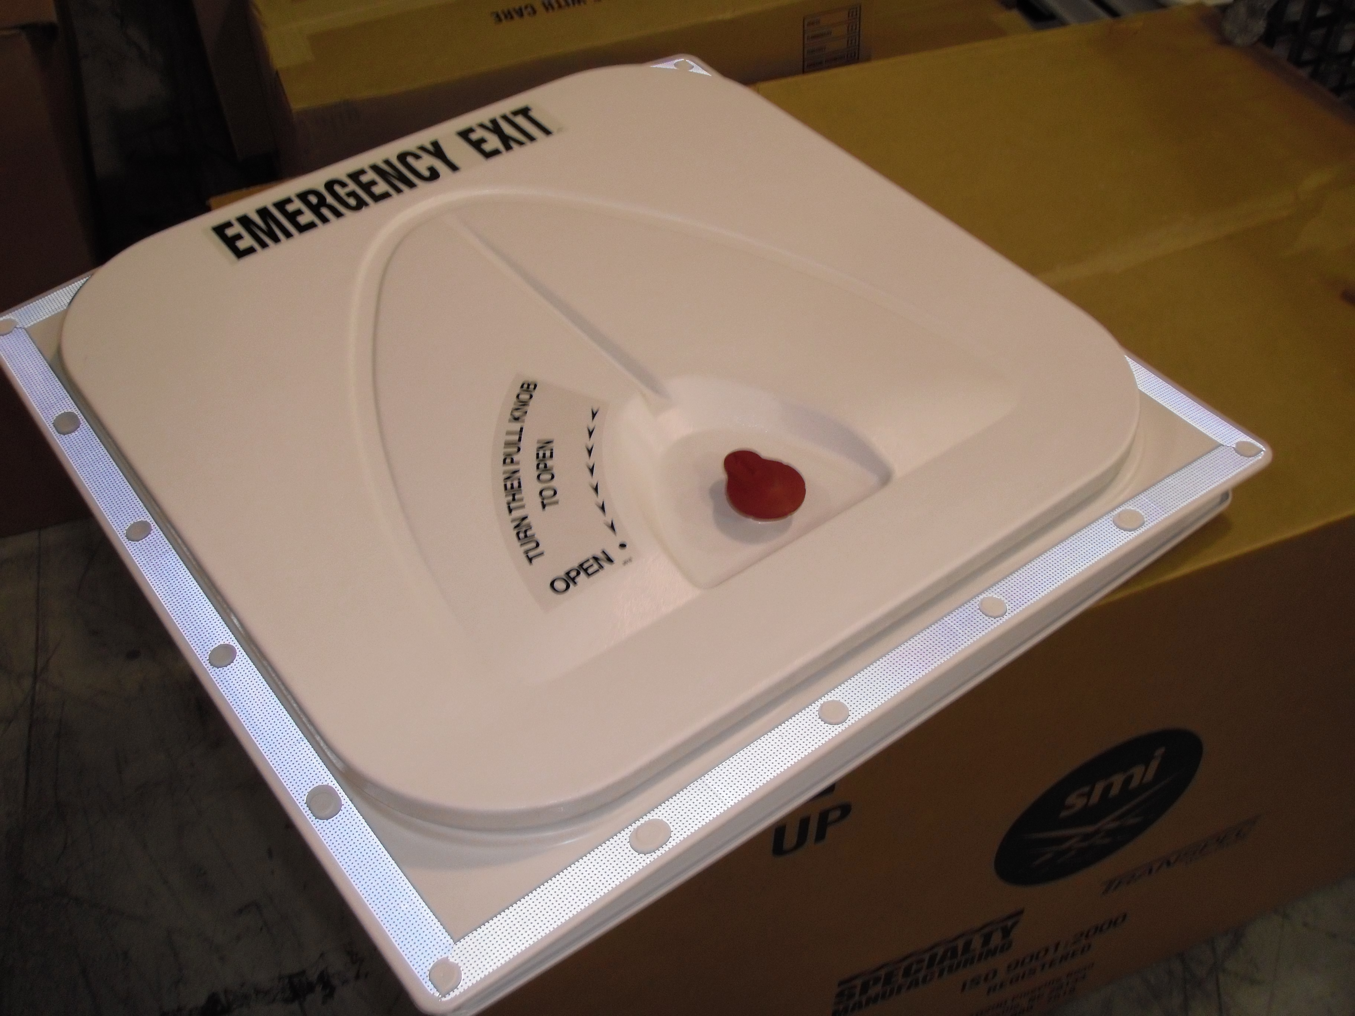

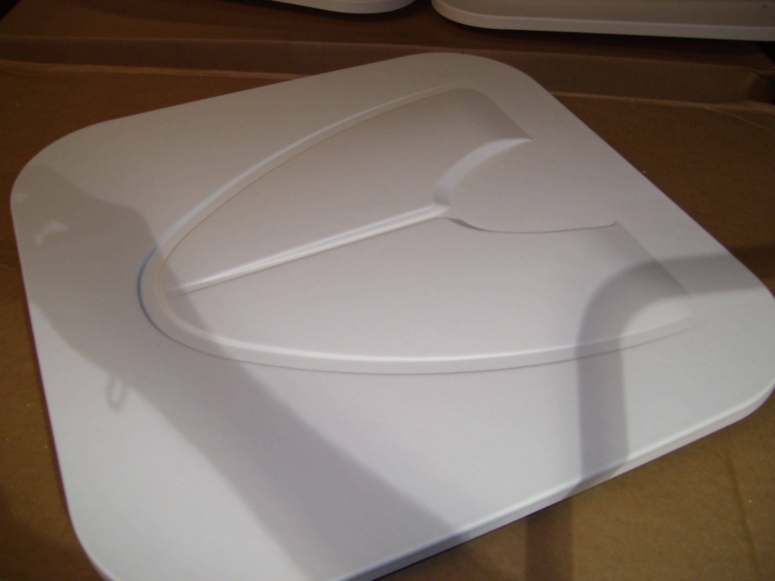

**Inside Release Hatch as of 2/15/09**

The lid will have the Outside Release features, but will not have the outer red release knob.

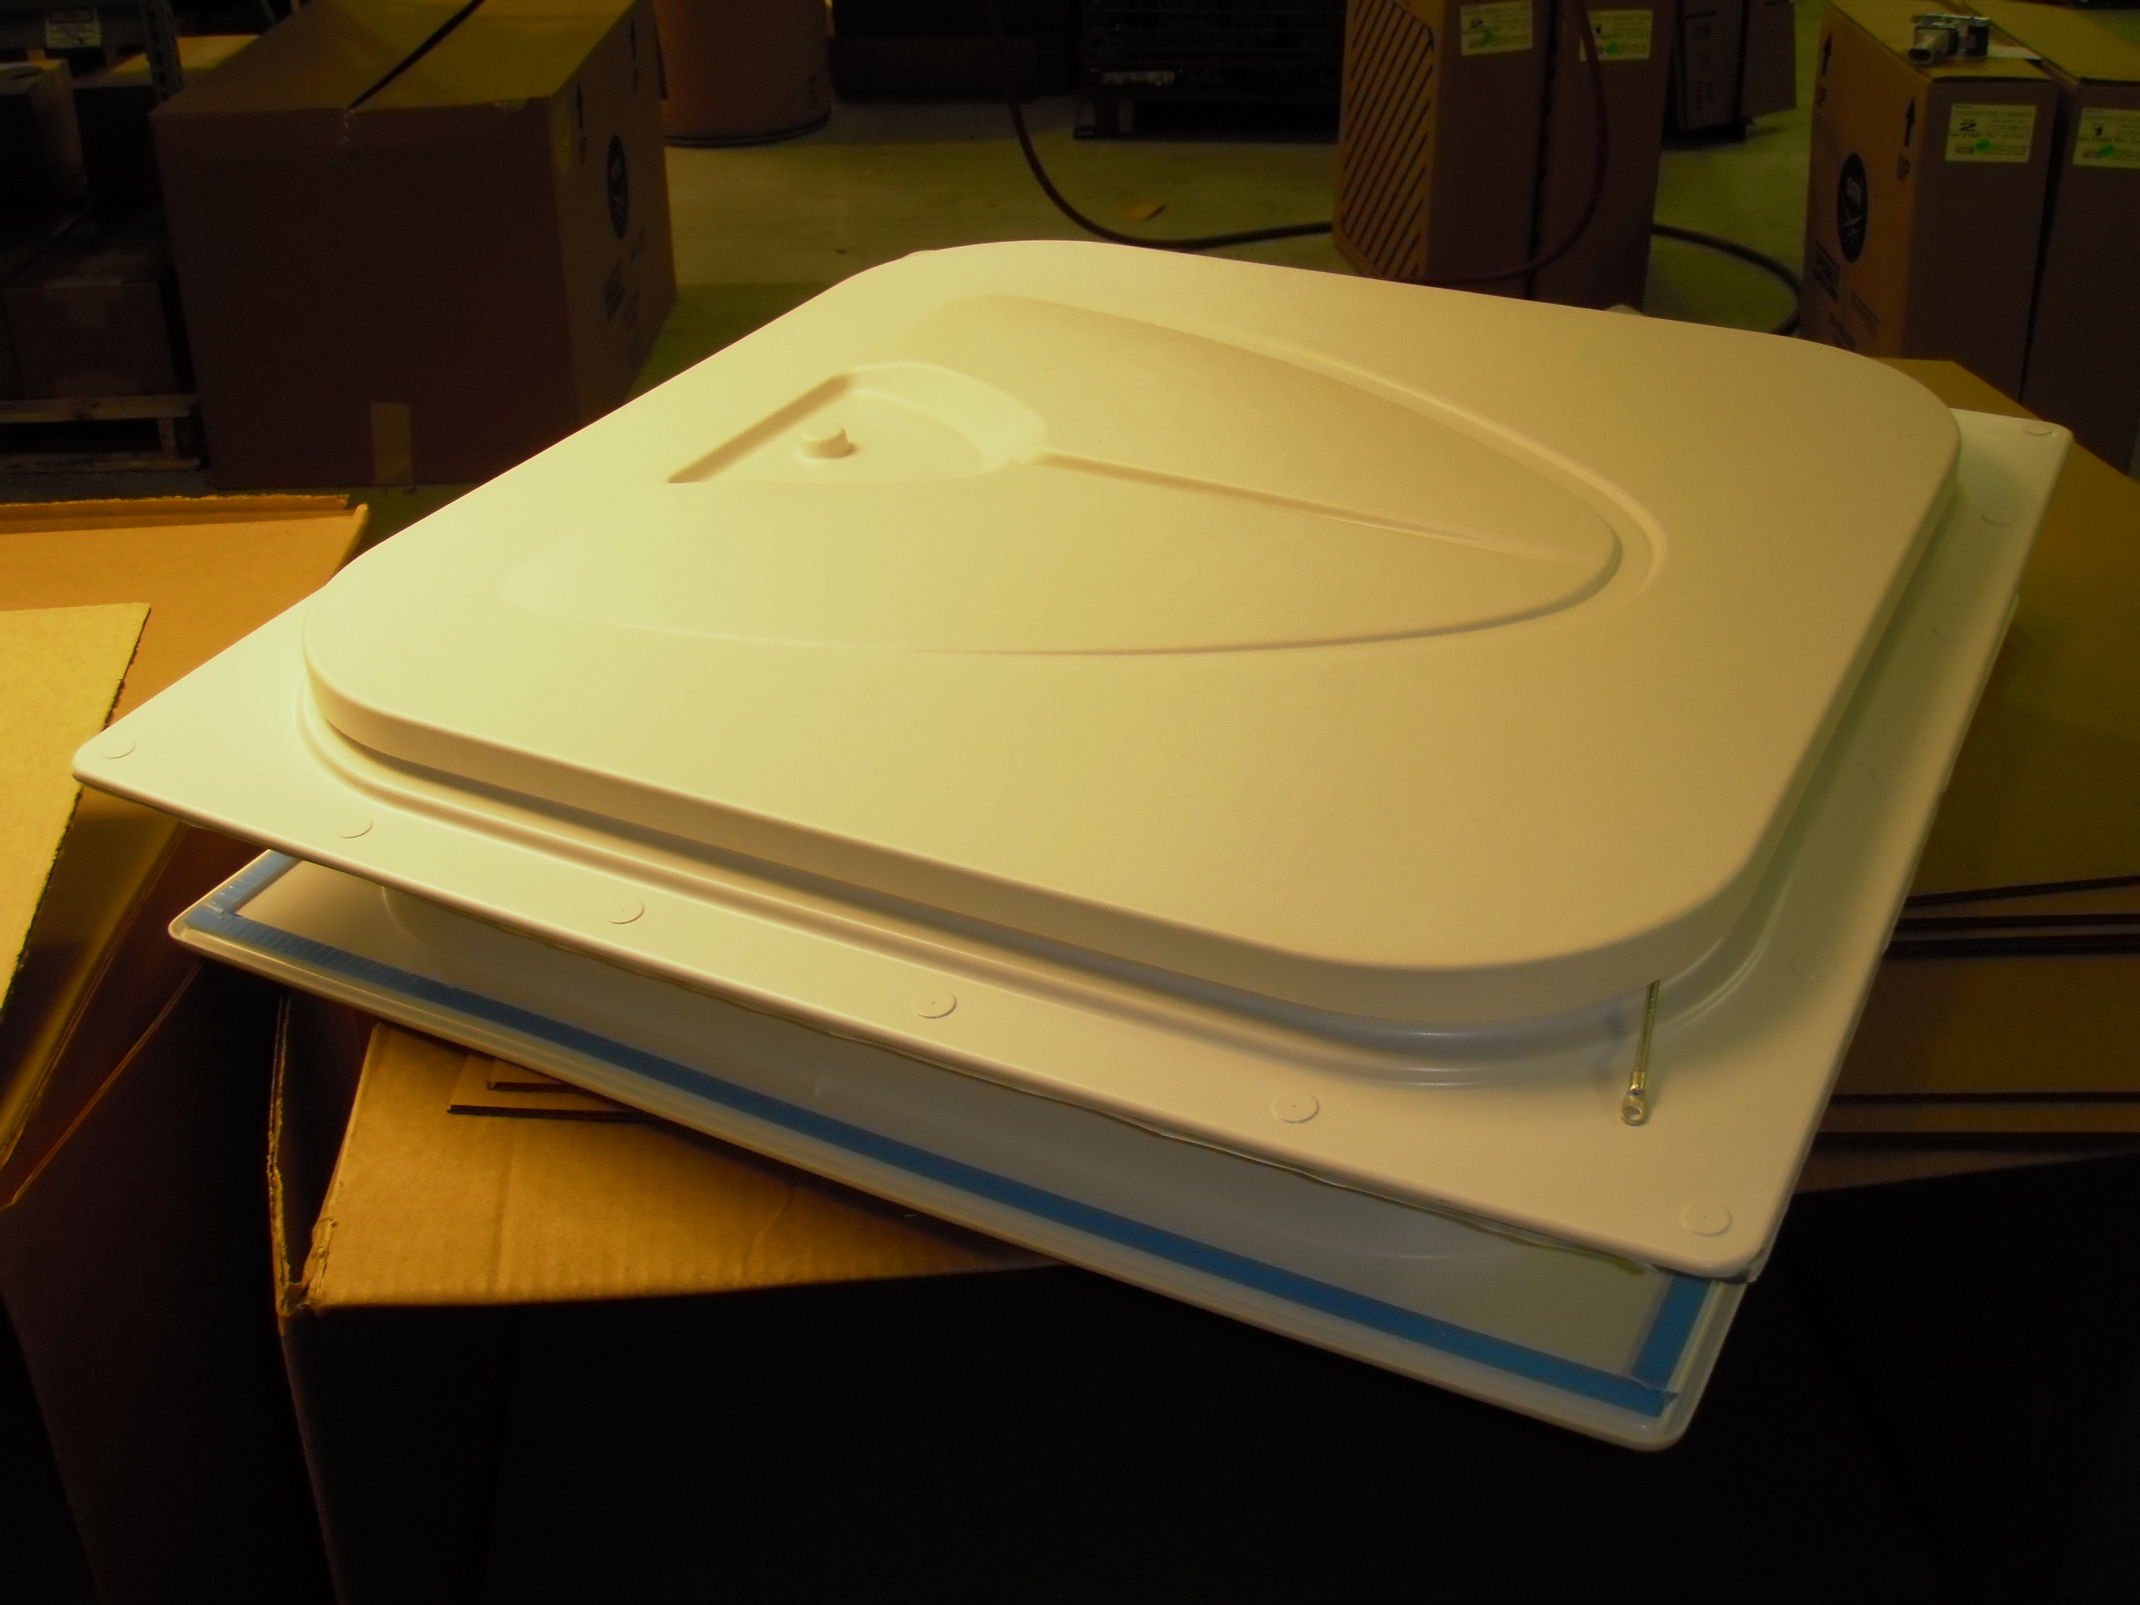

Previous Inside Release Style Lid (no bump)

Outside Release Style Lid w/ Red Release Knob