Functional Diagram
Sentinel Module (5.5- SERIES)

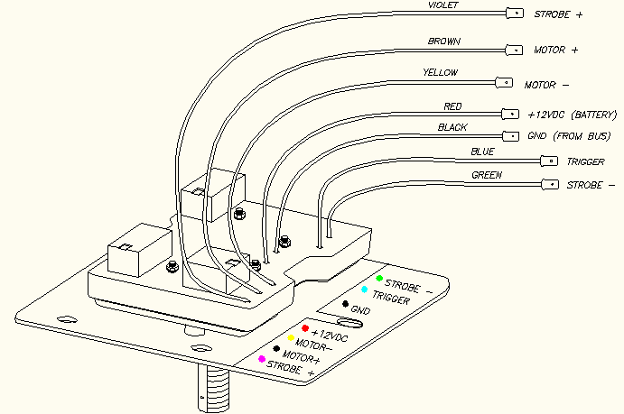
*NOTE: Strobe Outputs used ONLY in systems using Strobe Lights.
(For Strobe Light troubleshooting see Technical Bulletin A412.)

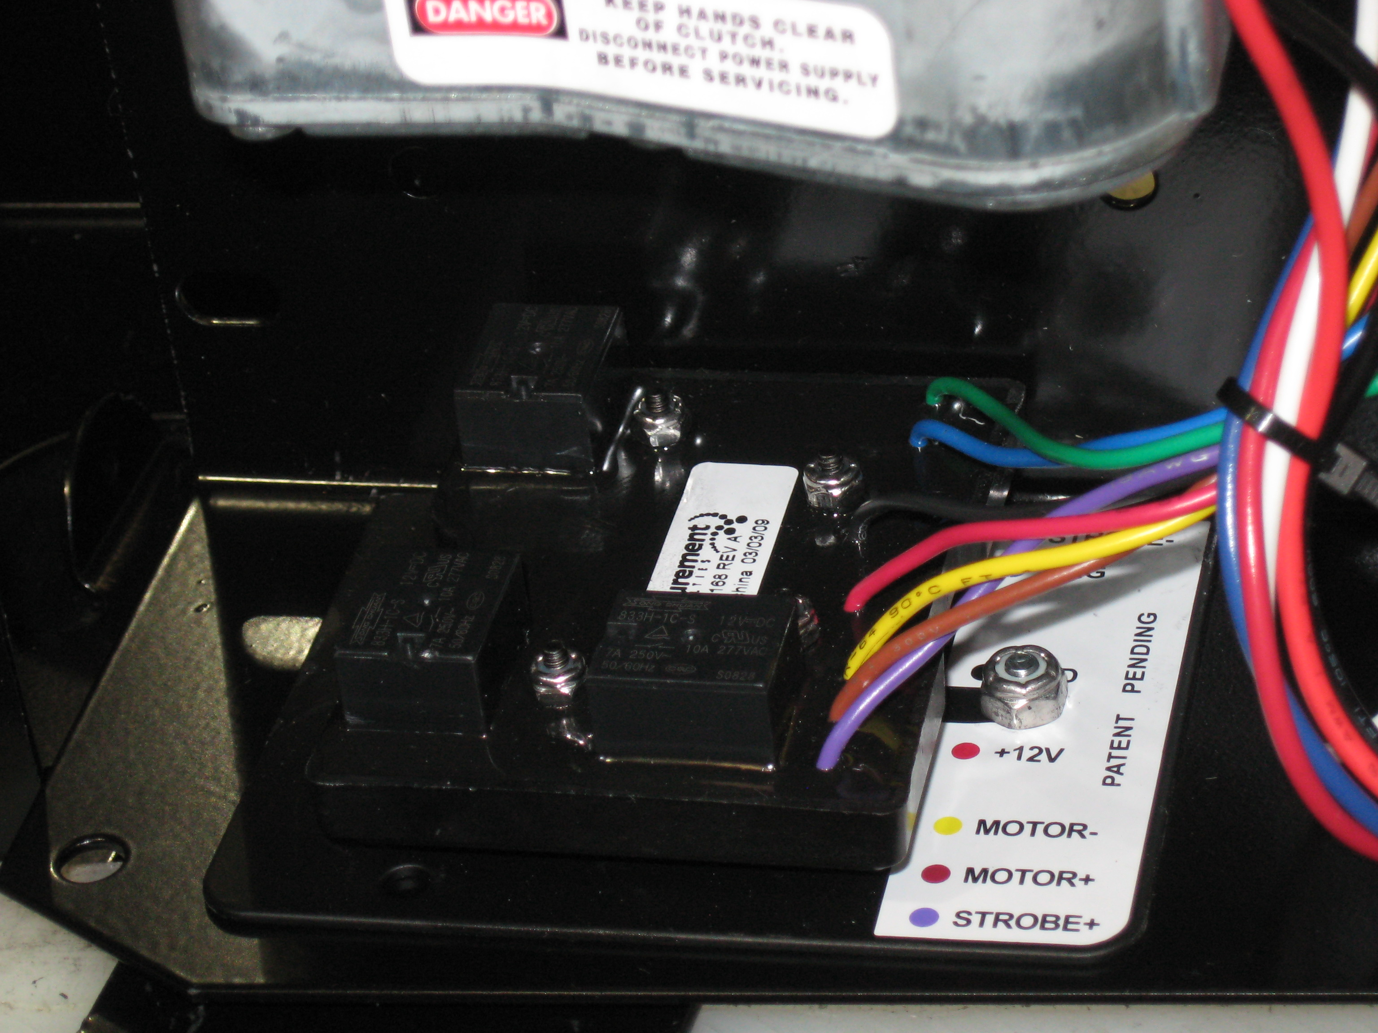
The Sentinel Stop Arm (5.5-Series) contains two internal circuits: a motor circuit and a motor control circuit. The motor control circuit is a semi solid-state Hall-effect, encapsulated module that senses the position of the arm and energizes the motor according to the control signal from the 4 or 8-light flasher system. When the 4 or 8-light flasher system is ON and the door is opened, the ‘Stop Arm Solenoid’ terminal on the flasher system provides a signal (+12V) to the control module via the Blue wire. The control module provides the proper voltage and polarity for the motor to move the hinge and attached arm to the OPEN position. When this signal is 0 volt, (door closed and lights off), the control module provides the proper voltage and polarity to return the hinge and attached arm to the closed position. The drive shaft has a magnetic property that is sensed by the Hall-effect sensor determining position of the hinge in relation to the status of the control signal and to start or stop the motor action accordingly. The Sentinel unit is internally grounded through the black wire, eliminating the possibility of faulty external chassis grounds.
While it may seem complicated, the Sentinel may be easily troubleshot using a test light or DC voltmeter (preferred). Please refer to the appropriate wiring diagram for the reference points listed.

*Note: Components that are determined to be ‘at fault’ are not necessarily defective. The fault may be due to loose connections and/or improper operating voltage. The situations listed below are those that may be encountered in the field. If further help is needed, contact customer service at Specialty Manufacturing.

Troubleshooting by Symptom

SYMPTOM 1: Unit is switched ON, 4 or 8-light flasher system is ON and the door is open causing the lights at the top of the bus to switch from Amber to Red, but the unit will not open:
- Pull the hinge fully open, remove the cover and then partially close the hinge. Check for voltage at the Red wire (+12 VDC, Battery) and Blue wire (driver input or trigger). The voltage should be 12V. If not, then check for a steady 12V at the “Stop Arm Solenoid” terminal on the 4 or 8- light flasher system. If this is not 12V, then the flasher system or wiring connections are ‘at fault’. If the voltage at these two points is 12V then proceed to step 2.
- Check the voltage at the Red wire (+12 VDC, Battery). If this voltage is NOT +12V, the power source on the bus is ‘at fault’. Verify the associated fuse or circuit breaker is okay. If this voltage is acceptable, proceed to step 3.
- Check for a proper ground at the Black wire. If no ground is found, check the connection of the White wire inside the bus. If this ground connection is okay, proceed to step 4.
- Disconnect the Yellow and Brown motor wires from the module and check the voltage across the terminals at Motor (-) and Motor (+) on the module. If this voltage is NOT the recommended (0V and +12V to OPEN) or (+12V and 0V to CLOSE), the module is probably ‘at fault’. One side is always grounded and the other at +12V when the motor should be running. If this voltage checks out, the motor is probably ‘at fault’ since it has the correct power to run if it was operational. The motor can be verified faulty by touching the Red and Black wire terminals of motor across a known good 12V voltage supply such as a battery or the live buss-bar and ground. If the motor runs during this touch check, the terminals crimped onto these wires may be ‘at fault’ or one of these wires may be shorted to the motor casing and gearbox.
- If the previous 4 steps do not identify the problem, and the problem still persists, the module is bad. Replace the module.

SYMPTOM 2: Motor is running but Unit does not open
- Verify RotoClip clamps are intact. If RotoClips are broken or worn, the clutch may
be slipping: replace RotoClips. (SMI p/n 005030)
- Verify shaft of motor is turning. If the shaft is not turning but the motor can be
heard running, then the motor is bad. Replace motor with SMI p/n 005014.
- If 1 and 2 above prove good, and the module is correctly wired, then the module is bad. Replace the module.

SYMPTOM 3: Unit operates properly, but continues to run after closing.
There may be an obstruction, check and/or clear any physical obstruction that may be present preventing the Stop Blade from returning to its zero position or flush against the bus.

*Note: The Sentinel module intentionally keeps the motor running for ~1 second after sensing the closed position to ensure the blade or gate is against the bus body or bumper.

SYMPTOM 4: Unit is switched ON, opens properly, but will not close after being switched OFF (door closed).

1) With eight-way flasher system OFF, pull the hinge fully open, remove the cover and then partially close the hinge. Check for voltage on Blue Wire (Trigger or Driver Input), should be 0 Volt. If this voltage is NOT 0V, check the voltage at the “Stop Arm Solenoid” terminal on the 4 or 8- light flasher system for a proper input signal of 0 Volt. The flasher system or the wiring connections to the unit may be ‘at fault’. If the voltage at these points checks out, proceed to step 2.
2) Remove the Yellow and Brown motor wires from the module and check the voltage across the Motor terminals. If this voltage is NOT within the guidelines (0V and +12V to OPEN) or (+12V and 0V to CLOSE), the module is probably ‘at fault’. If this voltage checks out, the Motor is probably ‘at fault’. The Motor can be verified faulty by touching the Red and Black wire terminals of motor across a known GOOD 12 volt voltage supply such as a battery or the live buss-bar and ground. If the Motor runs during this touch check, the terminals crimped onto these wires may be ‘at fault’ or one of these wires may be shorted to the motor casing and gearbox.
3) Verify ground connections: check ground from White wire on bus to chassis ground. If it’s bad,
replace ground wire on bus.
- Verify Roto-Clip clamps are intact. If Roto-Clips are broken then replace Roto-Clips. (SMI p/n 005030)

SYMPTOM 5: Unit is switched ON, opens properly, but moves back and forth about 3 to 4 inches on the blade tip, commonly called “oscillation”, OR
Optional Strobe Light either operates erratically or not at all. The Voltage at the Blue wire
is below 12 Volts.
This is typically caused by the signal voltage from the 4 or 8-light flasher NOT being steady or by a low voltage condition originating with the 4 or 8- light flasher NOT supplying enough source voltage. Measure this voltage preferably at the 4 or 8-way flasher terminal labeled STOP ARM SOLENOID or at the Blue wire input to the module (Driver Input or Trigger)

SYMPTOM 6: Stop Arm is switched ON, opens past 90° and continues to open until it hits the front of the bus.
Check to be sure the motor outputs are not reversed on the connector terminals on the module. If the motor wires are connected properly and this problem exists, the module is bad. The module needs to be replaced.

SYMPTOM 7: Stop Arm is switched ON and blade opens to another position significantly less than 90°
OR significantly greater than 90°.
Check and verify module is wired correctly and the timing mark is in the correct orientation. If this IS true, the module is bad. Replace.

