- 0The recommended hole size for proper roof hatch installation is 23.5” x 23.5” with 3.5” radius corners. Cut out the template supplied on the roof hatch box. Place the template at the desired location in the center of the bus roof, avoiding any bows, ribs, rivets, etc., by at least 2” where possible. Trace the template pattern on the roof.

- Using a 5/16” drill bit, drill one hole at each corner of the template outline all the way through both the roof and headliner of the bus.
Note: the holes must be drilled straight down, perpendicular to the ground, or floor of the bus.

- Cut the hole in the roof using a panel cutter or similar tool. The hole edges should be straight with no jagged edges and minimal distortion.

- Remove the cut roof piece and any insulation between the roof and headliner. Inside the bus, place the template on the surface of the inner liner aligning the corners with the four holes as with the roof panel. Trace the outline of the template on the headliner.

- As before, use a panel cutter to cut the hole in the headliner. Cut the hole to the inside of the traced line. If the roof hatch is equipped with a handle ajar micro-switch, it should be wired at this time.

- The roof surface surrounding the hole should be clean and dry prior to installing the hatch with butyl tape on mounting flange. Taking care not to damage the handle ajar micro-switch, lay the hatch in the hole with the hinge facing forward toward the bus front and position the hatch in the center of the cutout.

- Using the pre-drilled holes in the hatch flange, drill through the roof at each location using the pattern shown in Figure 1. Tighten the screws to 5 – 7 ft-lbs of torque, being careful not to strip the screws in the sheet metal or cause significant deformation of the mounting flange. For hatches with a 373”R & no pre-drilled holes the manus bond tape will bond with proper clamping. A bead of silicone sealant may be applied to the edge of the mounting flange & roof and screw heads if applicable.

- Position the inner trim ring in place, making certain the curvature of the trim ring is aligned with the curvature of the bus headliner. If equipped with pre-drilled mounting holes, use self-drilling screws to secure the trim ring to the headliner. The trim ring may also be attached by drilling screws horizontally through the trim ring and mounting frame, leaving no fasteners exposed on the bottom of the trim ring.
Note: Do not over tighten the mounting screws as the trim ring may warp.

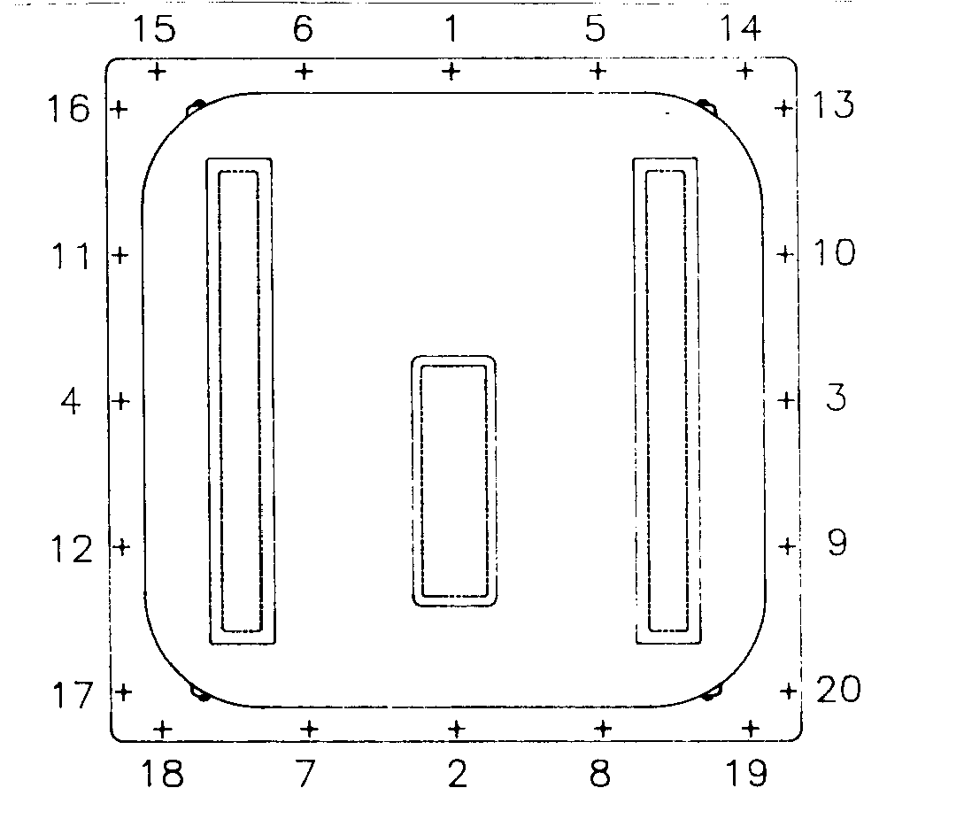

Fig. 1 Screw Installation Pattern

