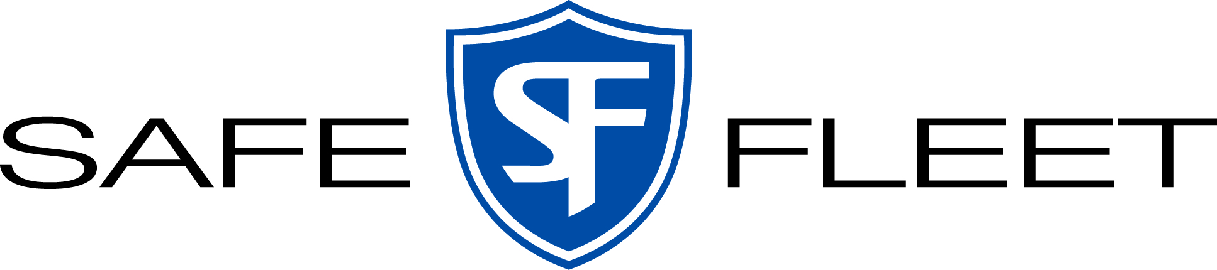
LTL & TL Delivery Routing Instructions

We are pleased to announce our collaborative logistics partnership with CH Robinson. We have partnered with them to manage our common carrier logistics operations. As an important supplier to the Safe Fleet group of companies, we look forward to your commitment to this new freight routing program.

CH Robinson’s web-based system, Navisphere 2.0, provides us with visibility and allows us better management of our freight performance. The program will encompass inbound and outbound freight.

If a Truckload shipment with special requirements is needed (Heated or Hazmat), please contact our traffic department four days prior to ship date.

Effective on all freight shipments (LTL and TL) scheduled for April 1, 2024 and forward, please contact Safe Fleet Traffic Department’s at:
safefleet@chrobinson.com

To schedule freight, please utilize Navisphere 2.0 with the account information you have been provided. If you do not have access to Navisphere 2.0 please reach out to safefleet@chrobinson.com to get set up. An account will be created so you can work directly in Navisphere 2.0.

Once you are set up and have access:

- Shipment details will be entered into Navisphere 2.0
- Carrier selection will be made in Navisphere 2.0
- Proper arrangement will be scheduled for pickup
- A Safe Fleet BOL can be downloaded from Navisphere 2.0. That BOL should have the carrier name and billing instructions on it. If you choose not to use the BOL, it is imperative that you use the correct carrier and complete the BOL showing CH Robinson’s billing information, The “bill to” section should read:
CHRLTL
14800 Charlson Road
Suite 2100
Eden Prairie, MN 55347

We anticipate and appreciate your cooperation with this new program. Failure to follow the above instructions may result in a charge-back of excess freight costs.

Thank you,

Safe Fleet Strategic Sourcing Team

